CAHSS Transition Plan
Version 7
25/02/2019

Introduction

1.1 Purpose
To implement the new Canadian Animal Health Surveillance System (CAHSS) governance structure and transition CAHSS to the National Farmed Animal Health and Welfare Council (NFAHWC)

1.2 Overview
The CAHSS history of activities supports a collaborative framework by member networks and provides a broad range of outcomes and elements worth building into a new CAHSS governance structure. The rationale for a transition of CAHSS to the NFAHWC reflects the need to find a sustainable infrastructure that is supported by a governance model centered on a collaborative industry and government framework which is in line with the recommendations that were made when CAHSS was first envisioned.
CAHSS is a federated network of groups and individuals involved in animal health surveillance in Canada. The intent is to encourage innovation and create solutions to enhance animal health surveillance in Canada. The network is largely autonomous with stable relationships between the various participating groups. Linkages are maintained through an agreement to work towards the CAHSS common purpose statement, using the CAHSS core principles to guide the work of the network and each network component. Participation in CAHSS is voluntary.

CAHSS Purpose Statement

A shared national vision leading to effective, responsive, integrated animal health surveillance in Canada.

Core Principles of Practice:

- Work to ensure the quality of life for Canadians by protecting animal health and public health,and supporting economic prosperity.
- Work to ensure scientific rigor and professional and technical competence, acknowledging that other factors must be taken into account in decision making.
- Encourage practices, behaviors and uses of technology that are consistent with the Purpose and Principles. In particular, encourage openness, collaboration and innovation.
- Resolve conflict compassionately, productively, cooperatively and respectfully.
- Freely and fully exchange information relevant to the Purpose while respecting confidentiality.
- Work to ensure clarity in animal health surveillance communications by providing relevant background and contextual information.

Core Principles of the Organization

- An Individual or Institution subscribing to the Purpose and Principles of the organization is deemed eligible for Owning Membership and participation.
- Have the right to self-organize around any event or activity consistent with the Purpose and Principles, encouraging innovation and flexibility.
- Conduct deliberations and make decisions by methods that reasonably represent all relevant and affected parties.
- Participating network members retain full authority to independently manage and implement their own roles, resources and priorities but agree to consult with other network members to find efficiencies and avoid unintended impacts that might affect the operations of other members or the network as a whole.

1.3 Assumptions and Constraints
- The CAHSS networks and the NFAHWC support the transition.
- Full transition should be implemented by April 1, 2019.
- Funding sources need to be identified to ensure sustainability.
- CFIA Financial Assistance Program expires on April 1, 2019 while funding and human resources are identified in order to help ensure continuity.
- All participants, individuals and groups agree to work towards the shared CAHSS purpose and to abide by CAHSS principles. This process is formalized through the signing of a membership declaration.

1.4 Proposed Governance Organizational 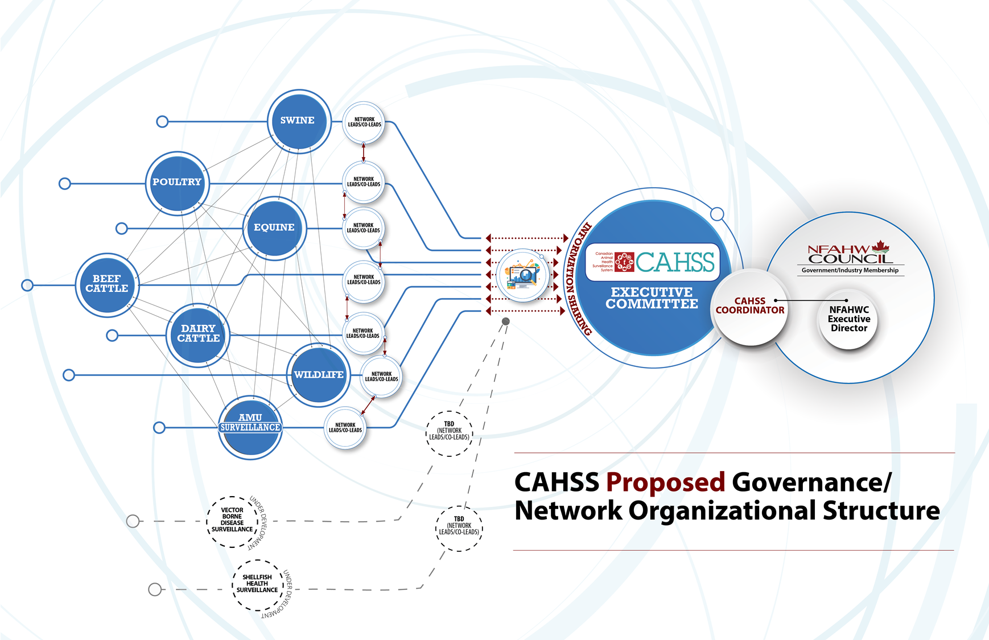

The NFAHW Council will establish a CAHSS section within the Council through a revision of the NFAHW Council by-laws. In order to ensure effective co-ordination and support, the Council and CAHSS organizational structure will be modified to reflect the needs as identified by the NFAHWC and the CAHSS Directors and Networks. It is recognized that establishing consistent and defined leadership roles and responsibilities will be critical to maintaining CAHSS progress. These key leadership roles and responsibilities are identified below:

CAHSS Coordinator: One individual, plus administrative support, hired by the Council and recruited jointly by Council and the CAHSS Executive Committee. Term of 3-4 years, with annual performance review by the NFAHWC Executive Director with input from the CAHSS Executive Committee.

The roles and responsibilities of the CAHSS Coordinator will include:
- Manage CAHSS network and Executive Committee co-ordination.
- Provide training and development on CAHSS for new co-leads and Executive Committee members.
- Support CAHSS Executive Committee in strategic planning to advance effective, responsive and integrated animal health surveillance.
- Co-ordinate the development of funding applications and CAHSS network plans, in cooperation with CAHSS Executive Committee, Council Executive Director and Network Leads/Co-leads.
- Initiate and coordinate meetings of the CAHSS Executive Committee and Network Leads and Co-leads.
- Manage day-to-day operations of CAHSS.
- Report to CAHSS Executive Committee and to Council on CAHSS performance and progress.
- Enhance collaboration with networks that are not part of CAHSS, building relationships with regional and species-specific networks to enhance information sharing.
- Ensure effective project management, budget management, network collaboration and co-ordination.
- Ensure oversight of CAHSS governance.
- Responsible for the general and active management of the business of CAHSS, and to facilitate the implementation of the decisions, strategic plans and policies as established by the CAHSS Executive and CAHSS network leads.
- Ensure the co-ordination of CAHSS Executive and CAHSS network calls.
- Establish new networks when gaps are identified and linking with other CAHSS, regional and sectoral networks, and assisting CAHSS networks in meeting targets and resolving critical issues as needed.
- Develop communication material content and social media content.
- Oversee website content.
- Liaise with external data sources, including laboratories.
- Organize network events.
- Recruit new network members.

CAHSS Executive Committee: 5-10 individuals, initially drawn from existing CAHSS Directors pool, and over time drawing from the pool of Network Leads and Co-leads and/or technical experts identified through a nomination and election process. Term of 3-4 years, with rotation, review and renewal needed to ensure representation across industry. A Chair and Vice Chair will be elected by the Executive Committee members. Two non-voting advisory members will be included who can provide alternative perspectives from federal or provincial governments or networks.

The roles and responsibilities of the CAHSS Executive Committee will include:
- Initiate strategic planning to advance effective, responsive and integrated animal health surveillance.
- Develop CAHSS policies.
- Identify issues and risks that adversely impact performance, recommend solutions, take appropriate action.
- Advise NFAHWC and CAHSS Co-Ordinator on issues that arise.
- Review and approve network or CAHSS reports.
- Meet with Network Co-leads and CAHSS Coordinator as required.
- Review and approve Executive Committee meeting minutes.
- Determine cross-cutting CAHSS networking priorities and common goals of existing networks (e.g. Standards for CAHSS networking supports, network performance indicators.
- Approve CAHSS Operational plans, including work plan and budget.
- Manage and provide input into the performance assessment for CAHSS Coordinator to the NFAHWC Executive Director.
- Report to Council on CAHSS policies, program and finances though the Co-Ordinator and the Executive Committee.
- Review projects proposed by Networks with a view to fostering alignment with CAHSS networking priorities, and providing project endorsement, as needed.
- Provide leadership in supporting and achieving the CAHSS common purpose statement and core principles.
- With the support of the CAHSS Co-ordinator - develop, implement and maintain governance, functions, structure and processes that apply to all networks, including the development and acceptance of formal procedural documents and establishing performance measures for CAHSS.
- Provide leadership in recommending the establishment of network groups when gaps are identified or the collaboration of network groups when duplication is identified.

Networks: CAHSS Networks have an inclusive membership with representation that may include industry, government, academia, and not-for-profit organizations engaged in animal health surveillance in Canada. Industry and government network champions help to promote the value, progress and activities of CAHSS to producers, commodity associations, government executives and other animal health surveillance stakeholders

Network Leads and/or Co-leads: 1 or 2 per national network, as needed and available, recruited directly by the constituent networks through their own process.

The roles and responsibility of the Network Leads and Co-leads will include:
- Initiate, coordinate and facilitate the efforts of each network to set priorities and respond to emerging and ongoing issues (network technical and management functions).
- Develop network work plans.
- Provide guidance on surveillance approaches and options.
- Access specialist technical expertise as required (e.g., CFIA epidemiologists, etc.).
- Share information with the CAHSS Coordinator, CAHSS Executive Committee and other Networks on network activities and accounts for coherence with CAHSS strategic plans to advance effective, responsive and integrated animal health surveillance.
- Collaborate with other national networks and establish linkages between common regional and species-specific networks.
- Lead calls and meetings of the network and network information sharing sessions
- Identify critical issues affecting the network and provide a forum for open and collaborative discussion and action, including overarching plans for communications and for improvement of animal health surveillance data.

.

Network Members: Maintain stable CAHSS linkages among existing and emerging regional, and sectoral networks as well as within and among CAHSS networks. Network members should establish or maintain linkages with individuals in sectors, specialty areas and geographic regions, and define membership criteria and recruitment process.

The roles and responsibilities of the Network members will include:
- Define the scope of network activities and set network priorities within the CAHSS network guidelines.
- Consult with stakeholders on issues and data needs/availability.
- Undertake steps to identify, clarify, and resolve emerging issues in animal health surveillance.
- Seek out and responding to stakeholder perspectives on animal health issues.
- Communicate back to stakeholders on issues of interest.
- Provide updates on network activities.
- Attend and actively contribute to network teleconferences.

NFAHWC Executive Director: One individual, plus administrative supports, recruited directly by the Council through their own process.

To empower CAHSS to function autonomously, the role and responsibility of the Council Executive Director with respect to CAHSS will be:
- Assess and ensure the alignment of the CAHSS strategy on animal health surveillance with the Council’s own overall strategy.
- Incorporate CAHSS workplan activities into the NFAHWC workplan and the Federal, Provincial and Territorial Regulatory Assistant Deputy Minister (FPT Reg ADM) work plans.
- Include CAHSS activities in FPT Reg ADM updates and briefings.
- Seek funding and administer contracts and CAHSS project/program funding and to explore options to identify sustainable long-term funding.
- Review jointly with the CAHSS Executive Committeeand coordinator the CAHSS strategic plans, CAHSS project/program plans delivery and outcomes.
- Enhance communication with stakeholders about the work of the Council and CAHSS and building on engagement and information sharing opportunities.
- Co-ordinate updates on CAHSS reports and budget to the NFAHW Council.
- Meet regularly with the CAHSS Co-Ordinator to discuss strategies and CAHSS activities.
- Manages CAHSS coordinator and provide annual performance evaluation, jointly with the CAHSS Executive committee.
- Provide support to CAHSS Co-Ordinator, Co-leads, and Networks as required.
- Participate in the development of performance measures.
- Assist with and participate in CAHSS Executive and Network meetings as needed.

NFAHWC: Composition of Council, recruited through their established process.
To empower CAHSS to function autonomously, the role and responsibility of the Council will be:
- With the CAHSS Executive, assess and ensure the alignment of the CAHSS strategy on animal health surveillance and the Council’s own overall strategy.
- As an advisory committee of the FPT Regulatory ADM Committee, provide CAHSS a platform to access the FPT Regulatory ADM table.
- Review, jointly with the CAHSS Executive Committee, CAHSS strategic plans, CAHSS project/program plans and outcomes.
- Work with CAHSS Executive Committee, CAHSS Coordinator to identify more sustainable sources of funding.
- Assume an Advocacy/Champions role.
- Hire and manage NFAHWC Executive Director

Transition Implementation Plan

The NFAHWC and CAHSS will establish a transition plan working group to develop and implement a transition plan to action Council and CAHSS organizational changes. The working group will consist of designated members from the NFAHWC and the CAHSS directors’ group, as well as from CFIA and AAFC which have been supporting the implementation of CAHSS to date. The target date of the CAHSS transition is April 1, 2019 however this will be dependent on funding and resource availability.

2.1 Description of Implementation
Once approved by CAHSS directors, the transition plan will be shared with CAHSS Networks in order to ensure the process meets the needs of CAHSS members. The transition process will be collaborative and will seek input and engagement from the CAHSS members on an ongoing basis as the transition occurs in order to ensure priorities continue to be met and continuous improvement can be undertaken where required.

2.2 Transition Plan Working Group Members
Role | Name
NFAHW Executive Director | Megan Bergman
CFIA | Ian Alexander
CAHSS Director | Claudia Gagne-Fortin
CAHSS Director | Glen Duizer
CAHSS Director | Grant Maxie
CAHSS Director | Betty Althouse

2.3 Major Tasks and Timelines

Tasks Requiring Completion for Successful Transition Implementation:

- Council Executive Director will participate in CAHSS operations discussions and CAHSS directors group calls in order to familiarize the council with CAHSS activities and responsibilities. Responsible: CFIA and Council Executive Director. Completed by: August 2018 - Complete

- Initiate working group to complete development and approval of implementation plan. Responsible: Council Executive Director and Co-Chair. Completed by: February 2019

- Discuss transition implementation plan with CAHSS directors and share with networks. Responsible: CFIA and Council Executive Director – March 2019

- Source funding to support networks, directors and the hiring of a CAHSS Coordinator and to assist CAHSS in transitioning to a new approach to governance as well as for contracts for supporting technical experts as required. Responsible: CFIA, Council Executive Director, CAHSS Directors, CAHSS networks. Completed by: March 2019

- Establish a CAHSS Executive Committee, and define Executive Committee composition, roles and responsibilities. Completed by: April 2019

- Develop position description and hire a CAHSS Coordinator. Responsible: CAHSS Executive Committee with CFIA and Council Executive Director. Completed by: April 2019 (funding dependent)

- Define budget and budget management process for CAHSS under the Council. Responsible: Council Executive Director, Council Co-Chairs, Council Corporation Directors. Completed by: April 2019

- Define administrative support requirements of CAHSS under the Council. Responsible: CAHSS Coordinator. Completed by: May 2019

- Establish reporting process between CAHSS and Council. Responsible: Council Management Committee and Executive Director and CAHSS Executive Committee. Completed by: April 2019

- Transition CAHSS budget and CAHSS oversight to Coordinator. Responsible: Council Executive Director, Council Corporation Directors, Management Committee. Completed by: May 2019

- Establish epi and technical expert contracts to support CAHSS networks and build leadership capacity within each network. Responsible: CAHSS Co-Ordinator. Completed by: May 2019

- Develop a communications plan to inform CAHSS network members and CAHSS stakeholders of transition of CAHSS to the Council and to provide updates of CAHSS achievements and future goals. Communications plan should include consideration for required communication tools, and face to face meeting requirements of CAHSS Executive and Network Co-leads to share information on network individual activities, and enhance collaboration between networks. Responsible: Council Executive Director, CAHSS Co-Ordinator, Executive Committee, Council Communications Working Group. Complete plan by: Fall 2019 for delivery on an ongoing basis.

2.4 Security and Privacy
All new Council Officers and CAHSS participants will be required to sign confidentiality agreements for the Council and for CAHSS. This will be accomplished using a modification of the CAHSS membership declaration.

3 Implementation Support
- Funding will be critical to establishing the required co-ordination, leadership, and governance transition to sustain and advance CAHSS
- Collaboration between CFIA CAHSS coordinator and NFAHWC Executive director in order to successfully transition the networks will be essential
- Participation of directors in the transition process will be critical in ensuring the needs of those in the network are met.

3.1 Outstanding Issues
- Sustainable funding to support a CAHSS Co-ordinator, epidemiological support, data analysis, communication, network meetings, and IT enhancements.

4. Performance Monitoring
Quarterly reporting on the status of progress on CAHSS priorities, workplan activities and budget will be required for the Council as well as for Council stakeholders by the CAHSS Coordinator with input from the CAHSS Executive Committee. Funding program requirements will also need to be met.

5. Risks and Contingencies
Failure to obtain approval for CAP funding will prevent this transition from occurring effectively unless alternative funds can be identified. Work will need to be undertaken if CAP funding is identified in order to identify long term strategies to maintain CAHSS operations past 5 years with the intent that the networks would become more self-sustaining and the level of co-ordination and management will be reduced.

6. Implementation Verification and Validation
Six months after the transition of CAHSS to the Council is completed, a thorough review of the established governance, structure, roles, and responsibilities will be conducted in order to ensure the implementation plan was successful and no further amendments are required in order to meet the needs of the Council and CAHSS. Feedback will be sought from all participating stakeholders to assist in refining the program management as needed.

